My Sister’s Gang Rape Fantasy

Codes: fmmmm+m
Characters:
Jason: Age 14, first person, me
Hannah: Age 15, my sister

This is a photo of my older sister Hannah. Hannah has gangbang and gang rape fantasies and I’m going to make her fantasy come true. For a couple of months, I have been making plans to do just that. Later I will describe how I am planning to make her gang rape fantasy come true. Also, I found out that Hannah masturbates to her gangbang and gang rape fantasies.

How do I know Hanna has gangbang and gang rape fantasy? She would never tell me and it took me a while, but I figured it out. It all started because I wanted to see her naked. Hanna’s bedroom is next to mine with a common wall in between, so I will explain how I found a way to watch her when she was dressing or masturbating with her door closed.

On our common wall, there were two electrical outlets (duplex receptacles back to back. They were inside plastic 2”x4” electrical boxes. When Hannah wasn’t home, what I did was to remove both receptacles, taped the wires and pushed them up into the wall. Then I cut the backs out of the electrical boxes. That left a 2”x4” opening all the way through the wall. Also, I bought these two wall plates for 30 cents each.

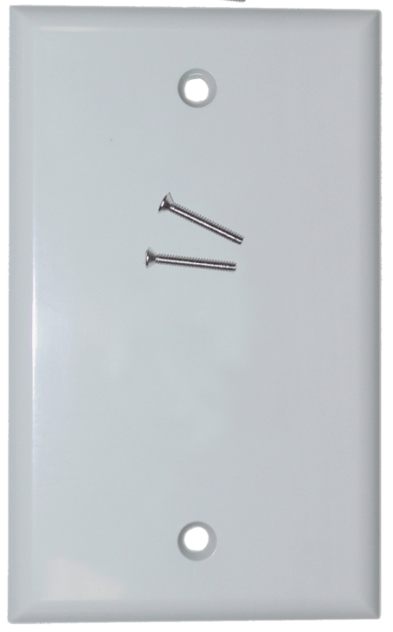

I put the plate with the big 1.5”x3.5” opening in Hanna’s room and I put the blank plate in my room. That way when the blank cover is on in my room, it is too dark to see anything through the hole. And, I knew Hanna and mother wouldn’t know what it is. They don’t pay any attention to it. Then, when I want to see Hannah, I make sure my room is dark so light from my room doesn’t shine through the plate in her room, and I remove the blank plate so I can watch Hannah through the wall and the 1.5”x3.5” hole in the plate in her room.

That is how I discovered Hannah was masturbating. Hannah would be in bed with the lights off. However, even at night, a little light comes through the window; enough light for me to see movement. Also, with the opening, I could hear Hanna. Hannah was not loud and without the opening, I may not have been able to hear her. However, every few second or so she would make these tiny sounds like ‘Eehh ooee iiiiieeeee mmmm’ so I knew was masturbating and having orgasms.

Then I read her diary. She locked it with a key and hid it in her diary in her closet, but I was able to find her diary, unlock it, and read it. I even found her spare key and drew the outline of the key on some paper. Then I make a key out a little piece of sheet metal. The key wasn’t difficult to make. I only needed put the metal in a vice and do a lot filing. Her diary key is small and simple, so it only took me a couple of hours.

Hannah’s diary was kind of cryptic, but I finally figured it out. For example, she wrote, “I watched alien gb and did it.” At first, that didn’t make any sense until after I got on her computer and copied her browser history. After copying, I could then go to the sites she visited without Hanna catching me on her computer. Hanna was watching a lot of Hentai porn gangbang and gang rape videos; and, one of the videos was Hentai Alien Gangbang. After that, I knew that GB and GR was gangbang and gang rape. And that was a night I could see, hear, and tell that Hannah masturbated. Therefore “I watched alien gb” meant Hannah watched Hentia Alien Gangbang and “did it” meant she masturbated.”

In the USA, laws against first cousins marriage are social and not based on science. The genetic risk of first cousin marriage is only 2% higher than the genetic risk between marriages where the husband and wife are unrelated. In fact throughout all history and still in many countries, most marriages were and still are between cousins. Other than the social stigma which is lacking any scientific basis, first cousin marriages are not a problem unless they are double first cousins and I can’t find any statistics on those. Double first cousins are 25% related. Also, half siblings are 25% related. I don’t know the genetic risk of half-sibling marriages, but certainly less than full siblings.

The reason that I am discussing that will become apparent in the next two or three paragraphs. I really really want to fuck Hannah. Hannah is not my full sister; she is my half sister and the result of my mother cheating on my father. I know that and, of course, mother must know it is a possibility. I don’t know that mother knows and I don’t believe my father or Hannah knows that father is not Hannah’s biological father. I don’t really care that mother cheated on my father. After all, most wives cheat on their husbands.

How do know that mother cheated two years before I was born? It is not complicated. I’ve always been curious and interested in science and last year, my science teacher was teaching about blood types. And my curiosity resulted in me asking each of my parents and Hannah their blood type. Our blood types are. Mother, type O; father, type B, I am type O; and Hanna is type A. Therefore, since mother gave birth to Hannah, it is not possible for my father to be Hannah’s biological father. And, the following chart makes that very clear.

Inherited Blood Type
Parent 1 | AB | AB | AB | AB | B | A | A | O | O | O
Parent 2 | AB | B | A | O | B | B | A | B | A | O
O
A
B
AB

Even though I knew from blood types that Hannah is my half-sister, I still saved up $100 for a DNA test on Hannah and me; and, definitely, Hannah is my half sister. If Hannah was my full sister, I don’t believe I would want to fuck as much as I do. But, my God! Hannah is sexy and beautiful. Hannah is better looking than me; she is a better athletic than me. She was a middle school cheerleader. Hannah is more popular than me; and, except for math and science, Hannah is smarter than me. She certainly makes better grades in school; almost straight A’s versus my B’s and C’s.

Although, it would be subconscious, probably why mother cheated is because Hannah’s father is more masculine and has greater bilateral symmetry than my father. There is a natural selection advantage for a woman to find a good provider and then, when ovulating, fuck a superior man.

Now I will describe how Hannah gets her fantasy to be gang rape fulfilled and how I fuck her. Hannah is probably a virgin since her diary doesn’t indicate that Hannah has fucked anyone. But, that doesn’t matter. She will not be a virgin after she has been gang raped twelve to twenty times by four or five guys. She will be a fucked dazed wreck, legs wide apart, her pussy full of cum, and babbling like an idiot.

As I stated in the very first paragraph, for two months I have been planning Hannah’s gang rape. I found the following four good looking boys; from left to right, and top to bottom Carter, James, Liam, and Michael. Their ages are 14 to 16 and they live twenty miles away. That way it is unlikely that Hannah will see them again in the unlikely event she reports the gang rape.

I chose young good looking boys because I know that in her fantasies, the guy that gangbang and or gang rape are going to be good looking. Her fantasies would not include ugly fat boys or middle age men. She would be grossed out. Also, I chose boys that are very nice. They will not be rough with her or harm in any way. They may have to hold her down. However, when they rape her, they will take their time to be as gentle as possible. I want Hannah excited and her pussy so wet that their cocks slide right in and are not forced in.

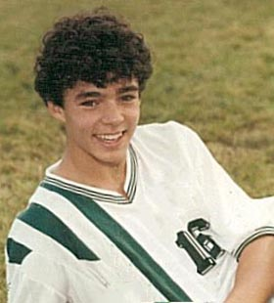
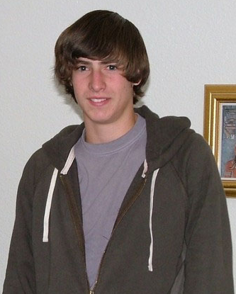

Also, this Asian girl will help. Friday afternoon, when Hannah is grabbed off the street and pulled into the van, at first she may be struggling and terrified. The girl will say, “Hannah, this is an abduction game. You are supposed to act like you are afraid, but it no fun if you are too afraid and upset. So will you just calm down and let us explain the game to you. “

Hearing her name, and seeing a pretty young girl her age, tell Hannah that it a game, will calm Hannah down and, of course, Then after meeting the four cute guys, Hannah will feel safe, the girl will leave and the four guys will take Hannah to an empty old farm house for a three day weekend.

I already showed the guys these two photos, proving that Hannah is a ‘Bitch.’ I said, “Women become bitches when they are not getting enough cock. So what Hannah needs is her pussy stuffed and pounded by your hard cocks.

After a couple of hours in the old farm house, Hannah calmed down and was flirting with the guys. Then Carter said, “Before taking you home Sunday, all of us are going to fulfill your gang rape fantasy and fuck you. Describe how you want us to rape you so that we can best fulfill your rape fantasy.”

“I don’t want to be raped. I don’t have any such fantasy.”

Michael chimed in and said, “Of course you do. You are on the internet most every night watching gangbang and gang rape videos.”

“No I don’t!”

“Yes, you do. Anytime you are on the internet, people can watch you and see the videos you watch.”

“You watch me on the internet?”

“Yes, of course,” Liam said butting in.

“Good grief! Is nothing private? And, even if I do, that doesn’t mean, I want to be gangbanged. Besides I’m a virgin and I’m going to stay a virgin.”

“I know you don’t plan to die a virgin nor even be a virgin at age 30 so can I be the one that gets your cherry?”

“Well! Perhaps by 30 or even 20, but there is a big difference from being age 15 to age 20 or 30.” So far Hannah doesn’t believe the cute guys would actually rape her and it is just part of their game playing.

“You agree that you are going to give it up. So why not now and get it over with. I promise that I take my time and give you are really good fucking with my rock hard cock.”

“I don’t have to explain. You are out of mind if you think that I will fuck anyone that asks me. I’m not going to fuck you and that’s that. I don’t even know you that well. “

“You will know me very well after we fuck.”

James entered the conversation and said, “Guys I know we agree we are not going to force Hannah to fuck us. However, that doesn’t mean that we can’t take her clothes off. Lay her on the bed and kiss her naked body all over. Then if we also suck on her titties and lick her pussy, maybe Hannah will beg us to fuck her so let’s do it—let’s strip Hannah naked.”

“Let go of me!” Hannah wasn’t afraid and with guys holding her arms, she was both struggling and laughing. “No, no don’t,” Hannah said as her top was unzipped. “Stop…Stop… Stop,” Hannah pleaded when after unzipping, the guys peeled off her top and then unsnapped her bra.

With Hannah bare above her jeans except for her bra dangling from over her shoulders and under her arm pits. James said, “Let carry and lay Hannah down on the bed.”

All Hannah can do is struggle and try to kick as four boys carry her by her arms and legs, lay her on the bed and pull and remove her loosely hanging bra. While Carter and Liam are consuming Hannah’s titties, James unbuttons her tight fitting jeans, then pulling and pulling, Hannah’s jeans slowly come off her hips and then quickly down her legs and off her feet. Then hooking his hands under each side, Liam quickly removes Hannah’s panties, crawls between the legs of the now totally naked Hannah, and starts licking her pussy.

Hannah is conflicted. She likes the attention from four sexy, good looking, guys about her age, and it is much like her fantasies, but fantasies are not real and, when the boys start taking off their clothes, this becoming all too real and could turn into a gang rape she is not yet ready for. However, with hands and kisses all over her body, her titties being sucked, and her pussy licked, Hannah moans. Liam takes that as permission to fuck and climbs higher and higher until his hard cock is in position to fuck Hannah.

However, Michael sees terror in Hannah’s expression and pulling Liam back says, “Get off of her.” With a hard cock, Liam at first, glares at Michael, but complies. Liam is not a bad boy and would not intentionally force himself onto a girl, but sexual passion and the extreme need for relief clouded his judgment. Michael who by several months is the oldest and somewhat the leader says, “Guy, I think Hannah has had enough for tonight.”

Then speaking to Hannah, Michael softly asks, “Are you okay.”

Seeing Michael as her protector, after wrapping a sheet around her, Hannah nods.

“Hannah, can we get you anything? Would you like something to eat or drink?”

“Can you take me home?”

“Not yet Hannah because we have all agreed that we would give you until Sunday for you to let us fuck you and fulfill your fantasy, but I will take you then or after you agree to let us fuck you.”

Not wishing to displease her protector, Hannah replies, “Okay, I can wait.”

Gathering and then handing Hannah her clothes, Michael says, “Guys, let’s leave and not pressure Hannah anymore tonight?

Hannah not wanting to alone with the other guys in the in the house, takes Michael’s hand and says, “Stay.”

When the other left and the lights, Hannah cuddled with Michael, and with Hannah feeling safe, secure, and in control, they kissed and then passionately kissed and explored each other’s bodies as the both became more and more sexually aroused. Hannah’s pussy was dripping wet and well lubricated as she willingly and eagerly allowed Michael‘s cock to plunge deep into and start pounding her pussy. Because Hannah was sufficiently aroused and lubricated, there was no pain or blood as she was moaning and making small sex sounds and almost cried out from her orgasm when she felt or sensed Michael squirting deep into her pussy.

Twice more that night they fucked and in the morning with everyone having breakfast, Hannah was cheerful and peppy as she chatted and flirted with all the boy. All morning Hannah and the boys talked, walked video, and played games. Hannah was relaxed and having fun.

By mid-afternoon, we played ‘Truth and Dare’ that included kissing in the closet for a minute and kissing and getting felt-up was turning me and soon the dares included removing an article of clothing and when I and the guys were mostly naked the dares included me kissing a guys cock. Then when I was on my hands and knees kissing Carter’s pretty cock, the guys started chanting “Suck it, suck it, suck it,” so I put in my mouth and started sucking. And, as I was sucking, Michael slipped his cock from behind and fucked me doggy-style.

Carter squirted toward the back of my so I swallowed and thought, ‘Cum doesn’t taste bad’ and it seemed to be a tiny bit salty. With Michael still fucking doggy style, Liam took Carter’s place and the fuck feast began. If a boy asked to fuck me I would say, “Come on.”

The guys called me and carried Hannah to the bed, blindfolded her tied her spread eagled on the. Hannah could only guess who was on top fucking her. With cum seeping out of pussy, I crawled on top and fucked my half sister. Hannah was fucked a couple before Michael untied her, took a shower with her, and took her home.

With a four guy plus me gangbang, Hannah was fucked about 15 times fulfilling her gang rape and gangbang fantasy. Hannah never knew that I was one of the guys that fucked. She would have killed me and my parents would have disowned me.

I never told anyone that mother had cheated on my dad when she had Hannah. That Hannah is my half sister is a secret my family would never know. I don’t believe my mother. Likely it was a one night stand and my father would have been fucking and mother really doesn’t want to know the truth.

Send comments: smjle4me@windstream.net

