Angel’s New Life Chapter one

Angel glanced at the tied and gagged body of her husband then looked at her watch it would be at least an hour before her husband regained consciousness and so she had plenty of time to prepare, she stripped off and went into the shower she grabbed her black dildo and pleasured herself thinking about what was to come this evening.
She smiled as she had got her mother to look after her two girls saying that she and her husband wanted a romantic evening together so the coast was clear , Angel got out of the shower and dried herself off and then walked to the dressing table and put on her make up after all a woman has to look her best, finishing up she put the ruby red lipstick on and then some lip gloss to really make her lips shine and smiled at the overall effect it created after all she wanted her husband to see her at her best.
Angel then turned her attention to her outfit, first she put on a black cup less Basque which supported her breasts but left them exposed, then she got a pair of sheer black silk stockings and slowly slid them up her shapely legs making sure there were no snags or wrinkles and clipped them onto the suspenders hanging down, Angel then slipped her feet into a pair of knee high black leather boots with 5” stiletto heels and slowly zipped them up.
She followed this with a black leather skirt which reached to midway between her thighs and knees and had a split up the left leg, she put on a cream silk blouse and left 3 buttons undone which showed plenty of cleavage.
Then she reached for the skin tight black leather gloves and slowly pulled them on over the blouse sleeves ensuring a nice snug fit in the fingers and then smoothing out the arms until they reached up to midway up her arm, she then walked over to the wardrobe and pulled out a cream silk jacket which showed plenty of cleavage and put it on.
She smiled at the reaction of her husband when he saw her dressed in this sort of outfit but she had to admit she felt evil and powerful dressed like this and hoped it would have the desired effect on people tonight.

Angel reached down and pulled out a sports bag and unzipped it and pulled out a thigh holster and putting her right booted foot on the bed put it onto the inside of her right thigh and then reached into the sports bag and pulled out a Smith and Weston 38 revolver and checked the chambers before sliding it into the holster and clipping it into place, she then pulled out a silencer and put that into the space provided in the holster.
Following this Angel pulled out a MAC-10 machine pistol and then a large bulbous silencer and with a gloved hand slowly screwed it onto the end of the gun, she then pulled out a magazine and with a gloved hand slammed it in, she reached over for a packet of cigarettes and lit it with a gloved hand and picked up a matching clutch put in under her arm and walked over to the full length mirror to see how she looked.
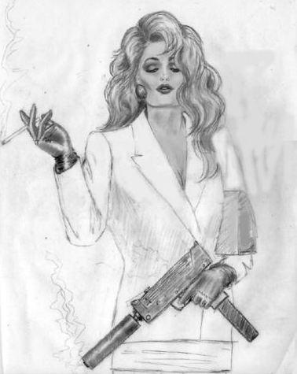

Angel smiled to herself and nodded she definitely looked like her name only she was an ‘Angel of Death’, checking the clock she saw she had 15 minutes before her other guest arrived and she savoured the cigarette fully as she anticipated the evenings events and placed the MAC-10 on the dressing table for easy access later.

The doorbell rang and Angel went and answered it, as expected it was her husband’s assistant who Angel had been flirting with and who she had enticed around this evening with a promise of some exciting fun, his eyes lit up as he took in Angel’s attire and she smiled as she noticed his reaction and leaned towards him for a kiss.

She pushed the door shut with a leather gloved hand as they embraced and then with a leather gloved hand injected him with the hypodermic syringe that she had hidden in her other hand, he fell to the floor and she dragged him into the bedroom and placed him on the dining room chair that she had earlier put there and handcuffed his hands behind the chair and using another ball gag she had brought from the sex shop some time earlier decided to wait for both of them to come around.

Angel passed the time by massaging her pussy with her leather gloved fingers she was surprised by how horny and wet she was and for a brief moment she thought about fucking both of them before continuing with the rest of her plan but shook her head as she had other plans.

She noticed that both of them were beginning to stir so she checked her attire and quickly freshened up her lip gloss as she wanted to look her best for their last moments.

Within a few minutes both men were awake and struggling against their bonds and Angel smiled as they noticed each other and then her, she had to admit she looked good as she noticed herself in the mirror cradling the MAC-10 and as she put her left leg on the edge of the bed the thigh holster came into view along with the top of her stocking exposing bare flesh and the grip of the pistol.

She calmly lit a cigarette with a lighter held in her leather gloved hand and as she exhaled a long stream of smoke she smiled and said ‘you are probably wondering what this is all about?’, Angel waited as both men their words and pleas muffled by their ball gags struggled for a bit and then resumed saying ‘Well l’ve decided that my present lifestyle is pretty boring, you my dear husband no longer satisfy me in fact our two daughters are more fun and l’ve come to the decision that l’d like to be a rich young widow and that means that you have to go!’

Smiling she continued ‘ Now your young assistant here is going to help me in this endeavour as l know you gave him a bad report last quarter and so any chance he has of promotion is gone unless he can change your mind, and so whilst l have gone out for the evening he has come here to forcibly change your mind and there’s a struggle and he produces this gun’ at this point Angel taps the MAC-10 ‘ You dear Husband reach for the revolver that we keep for self-defence and fire two shots as you lay there dying’

Angel hitches up her black leather skirt and shows them the thigh holster and smiles her leather gloved hand fingers her wet pussy and she continues with a laugh saying ‘why l do believe l’m getting wet and horny just relaying what is going to happen to you both, oh l wonder what it will be like for real, ah l hear you say but you won’t get away with it. Well gentlemen l have a date with two nice virile men the local police inspector and his 19 year old son who will verify my whereabouts, but first I have some time to spend with you two gentlemen’.
Angel reached down with a leather gloved hand and undid her husband’s assistants trouser belt and unzipped his pants and pulled them down exposing his 7” cock which was semi-erect, she licked her lips and grasping it with a leather gloved hand pulled the foreskin back and with a leather gloved nail circled the head of his cock which started to get really hard and Angel smiling looked over at her husband and said ‘You know what dear it seems such a shame to let a hard cock like this go to waste l think I’ll make good use of it’ with that Angel hitched up her skirt and facing her husband lowered herself onto the hard cock.

She lit up another cigarette and slowly started rocking forward and back establishing a nice comfortable rhythm and getting his hard cock to stimulate her clit, she smiled as she saw her husband’s cock begin to twitch and show signs of life and taking another drag of her cigarette said ‘why dear l do believe that me fucking another man in front of you has got you all horny, why if l had known that earlier we wouldn’t have been in this position’

Angel started to feel the beginnings of her own orgasm and reaching down with a gloved hand used her long leather covered finger nails on his balls and she was pleased to feel him respond and her orgasm built up just as his cock spurted a load of spunk into her wet pussy, this was enough to trigger her own orgasm and she screamed as she came.

Angel quickly did his trousers up and tapped him around the face with a leather gloved hand saying ‘Good stud, you gave Angel a good load and made her cum as well, for that you will be rewarded’, looking at her husband’s hard cock Angel smiled and moved over and lightly stroked it with a leather gloved finger and saw it twitch.
Looking up at him Angel blew a stream of cigarette smoke into his face and laughed saying ‘I believe hubby likes me dressed like this and touching him with her leather gloved hand, now before l deal with hubby’s hard on l believe hubby should do something for his wife’ she laughed in a manner which sent shiver down the spines of the two men present.
Angel clambered onto the bed hitching up skirt showing her stocking tops and the holstered pistol and removed the ball gag from her husband’s mouth he spluttered and then snarled ‘Ok you’ve proved your point let me go and l’ll fuck you and l’ll remember to pay more attention to you in future’.
Angel put a leather gloved finger across his lips and said in a cold menacing voice ‘Just shut up dear, there is no future for us and it’s me that will be doing the fucking once you have licked me out’ before he could sputter a reply Angel sat on his face and screamed ‘ Now lick me clean you bastard’ she brought the lit end of her cigarette against the hairs of his balls and burnt several of them and as he opened his mouth to scream Angel released a flow of pee into his mouth, she started wanking his hard cock with her leather gloved hand and within seconds she felt it begin to twitch and she brought her mouth down and took it into it and sucked his cum into her mouth.
Angel smiled as she licked the last bits of cum off his softening cock and got off the bed she quickly checked her make-up and retouched her lips and smiling at her husband said ‘Well dear l should look my best for you shouldn’t l’ with that she issued another cruel evil laugh and picking up the mac-10 walked to the end of the bed and checked the silencer was screwed on properly.
With that she stood in front of her husband at the end of the bed and took aim with the MAC-10 and fired ‘phht,phht,phht,phht,phht’ the dum – dum bullets ripped through his body and Angel felt an orgasm hit her, she placed the MAC-10 on the bed and pulled the Smith and Weston 38 out of the thigh holster and then removed the silencer and screwed it onto the end of the barrel and smiled at the young men who by now had peed himself and smiled saying ‘ No hard feelings’ and pulled the trigger twice ‘ Phht, phht’ both bullets crashed into his skull blowing the back of his head away and splattering blood and brain matter all over the wall.
Angel quickly checked both men for pulses and once she confirmed that they were both dead she removed the ball gags and the restraints and placed the Smith & Weston 38 in her husband’s hand and the mac 10 in his assistant’s hand, she removed the two silencers and placed one back in the bag and the other in the thigh holster and removed a nickel plated Smith & Weston 38 from the sports bag and placed and clipped it into her thigh holster.
Checking around the room Angel cleaned up the cigarettes and put them into a garbage bag and using a make-up remover cloth removed the traces of lip stick from his flaccid cock, Angel then checked her make-up and hair put a watch onto her right wrist and zipped up the sports bag.
Angel grabbed a coat and her clutch bag and picked up the sports bag to store back in the train station for later retrieval and blew a kiss at the occupants of the room as she left for her date and the start of a new life.
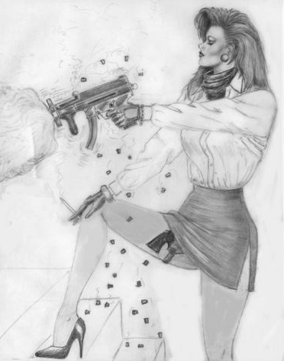

The end (or beginning of something new?)

